Ansible lab set
- Create two instances with amazon linux (give names ansible-server and host-server)
- Connect two instances
Execute following commands on ansible server 👇
sudo yum update -y
sudo dnf update -y

sudo dnf install -y ansible

sudo curl -o /etc/ansible/ansible.cfg https://raw.githubusercontent.com/ansible/ansible/stable-2.15/examples/ansible.cfg

ansible --version
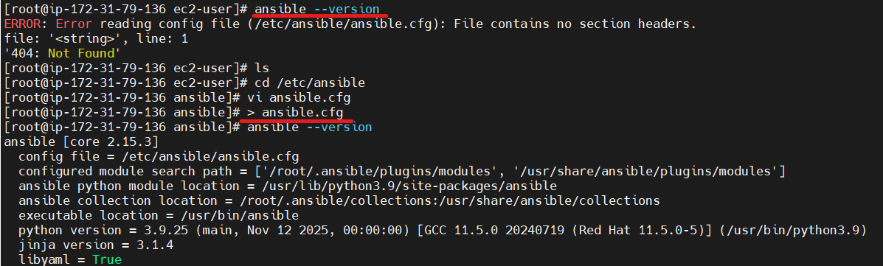

cd /etc/ansible

# open ansible ansible.cfg and add below lines inside the file

[defaults]
inventory = /etc/ansible/hosts
host_key_checking = False
retry_files_enabled = False
sudo_user = root
vi ansible.cfg
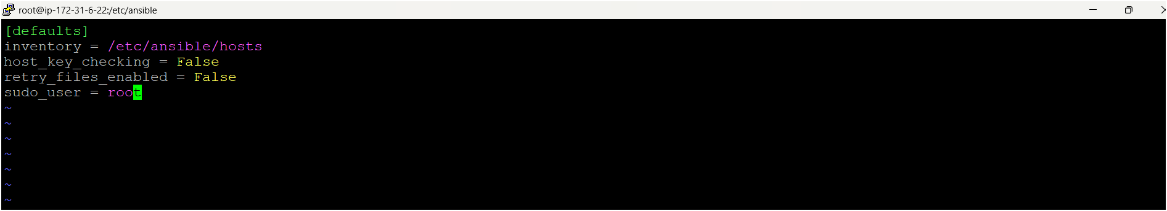

# create a file named hosts after open hosts file and add webservers and add your target machine pvt ip add
vi hosts
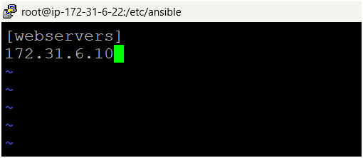

- Come to home directory
cd /home/ec2-user
- Create one user for ansible
useradd ansible
- Set a password for this user
passwd ansible
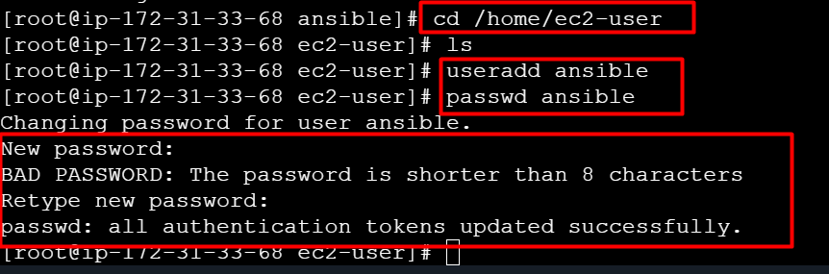

- Become as a ansible user
su - ansible
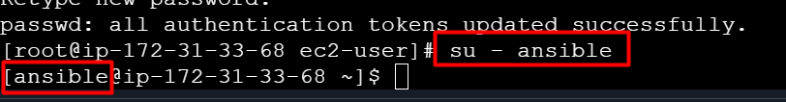

- Next you need to provide sudo privileges to ansible user (exit from the ansible user)
- Open visudo file
visudo
add this command under Root line ansible ALL=(ALL) NOPASSWD: ALL
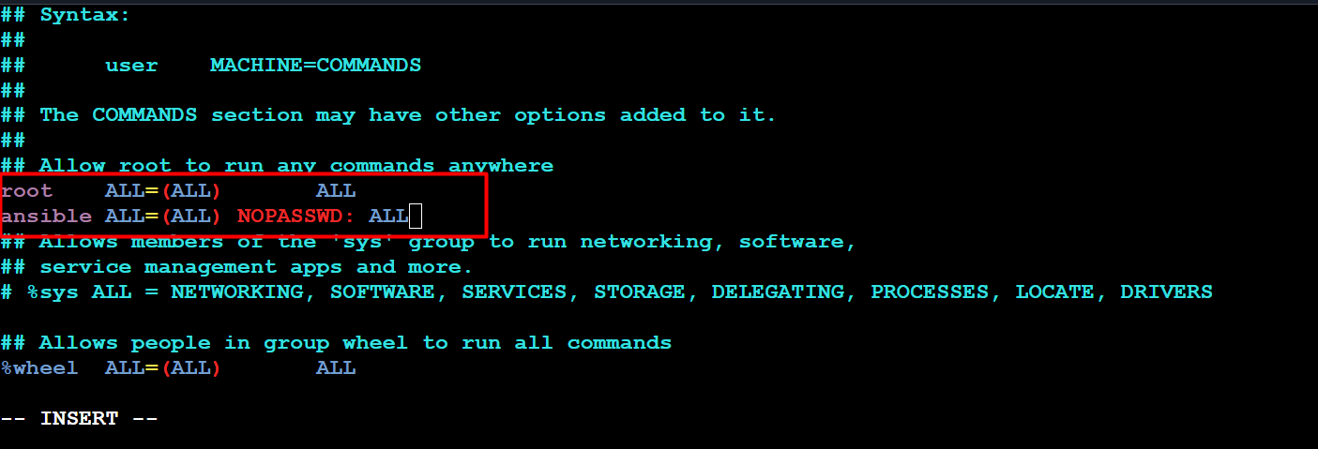
- Now create one ansible user on host-server/target machine as same as ansible-server and give same password here.
- Open visudo file and give sudo privileges to ansible user
visudo
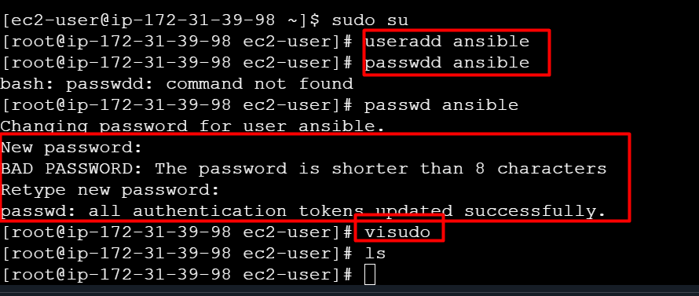
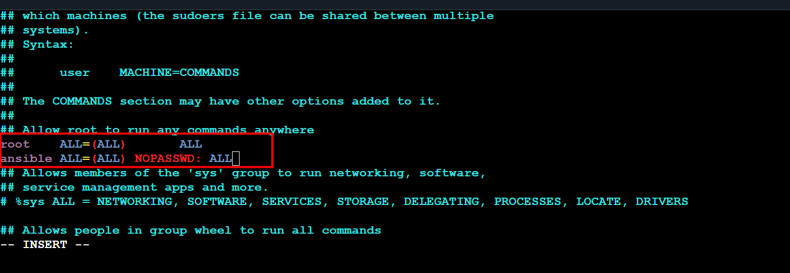

- We have to establish connection between ansible server and host server, follow the below steps on ansible server
- Open file /etc/ssh/sshd_config
vi /etc/ssh/sshd_config
- Uncomment for PermitRootLogin prohibit-passwd but remove prohibit-password replace with yes and find out this line passwordAuthentication no but remove no replace with yes
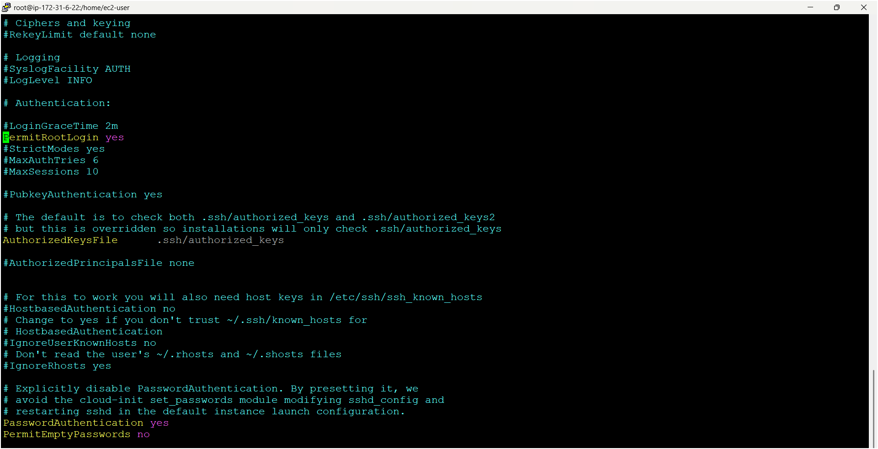



- Same steps do for host-server also ☝️
- vi /etc/ssh/sshd_config
- Uncomment for PermitRootLogin prohibit-passwd but remove prohibit-password replace with yes and find out this line passwordAuthentication no but remove no replace with yes


- Now you need to check connection between ansible-server and host-server
- Next you need to restart servers both ansible-server and host-server
service sshd restart (on both servers)
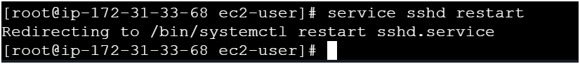
- Now become as a ansible user on ansible-server
- Next Copy pvt ip address of host-server
- Go to ansible server use below command
ssh <pvt-ip-add> (#host-server pvt ip add)
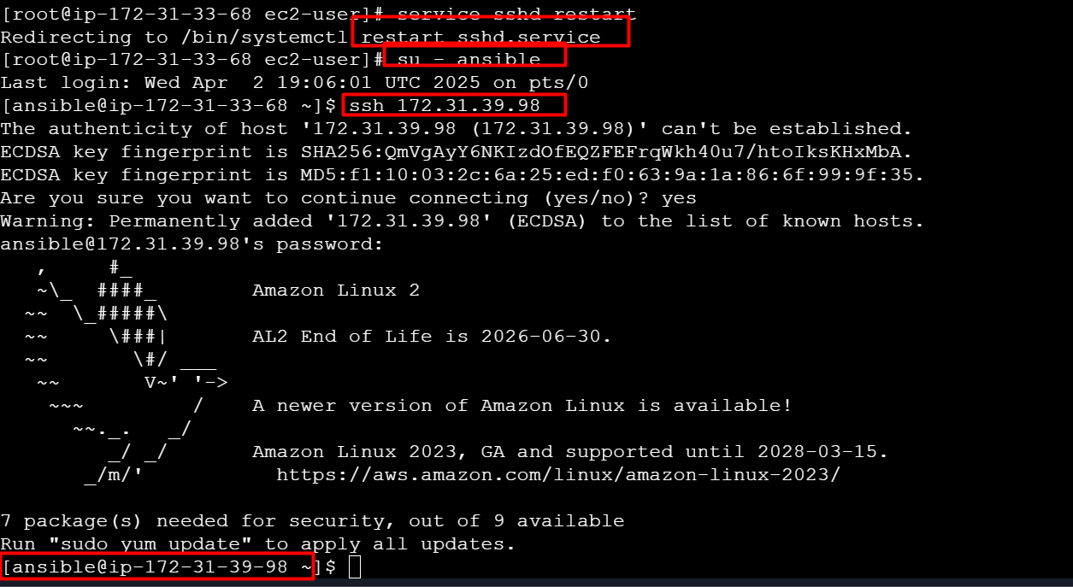
- Now its connected to your host-server (check pvt ip add of host-server)☝️
- Next exit from the host-server

- Now you need to make connection between servers without providing password and follow below commands on ansible-server 👇 (run commands as an ansible user only)
ssh-keygen (it will generate two types keys one is public key & pvt key)
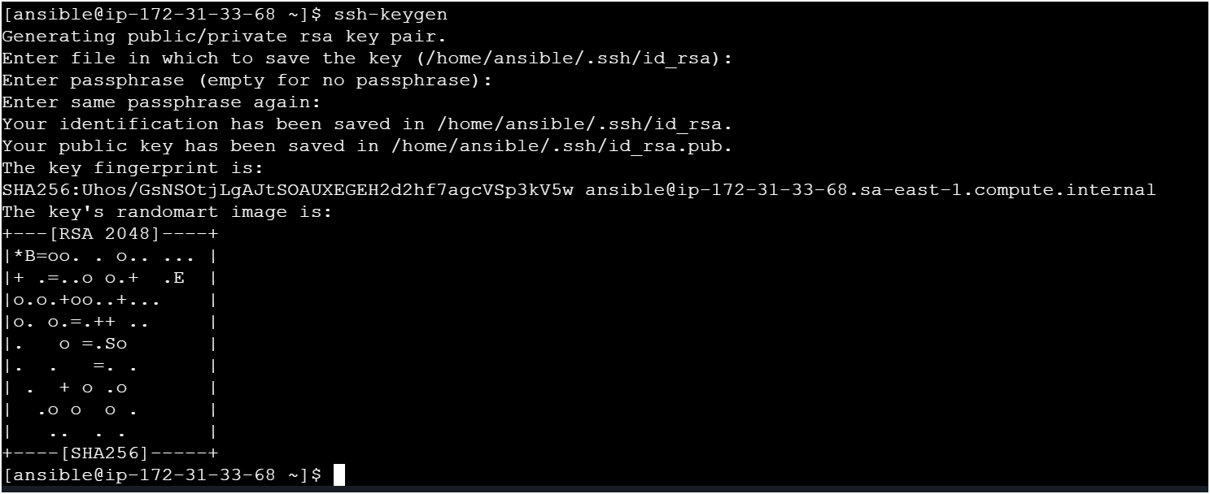
- Now look for key using
ls -la
cd .ssh
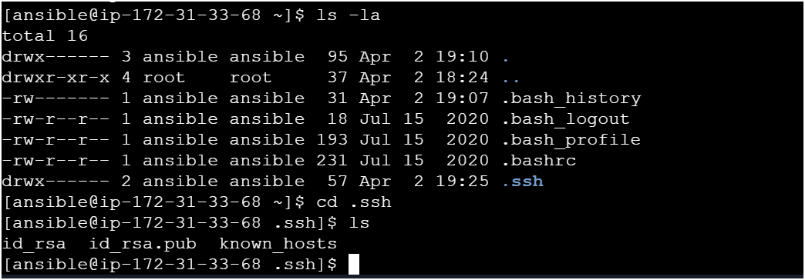
- How to copy public key to host-server from ansible-server 👇
ssh-copy-id ansible@pvt-ip-add-of-host-server and it will ask passwd provide ansible user passwd only 👇
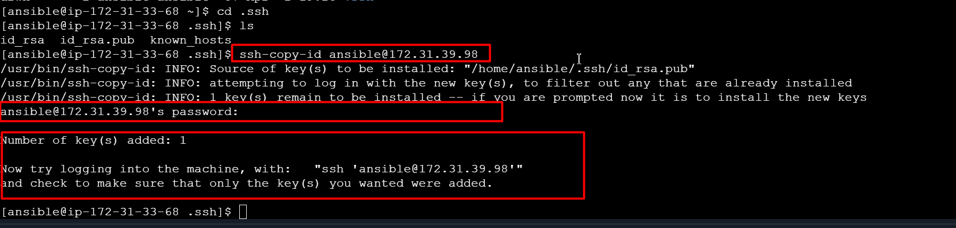

- Now do cross check by login to host-server from ansible-server without providing any passwd using below command 👇
ssh <pvt-ip-add> (host-server-pvt-ip-add)
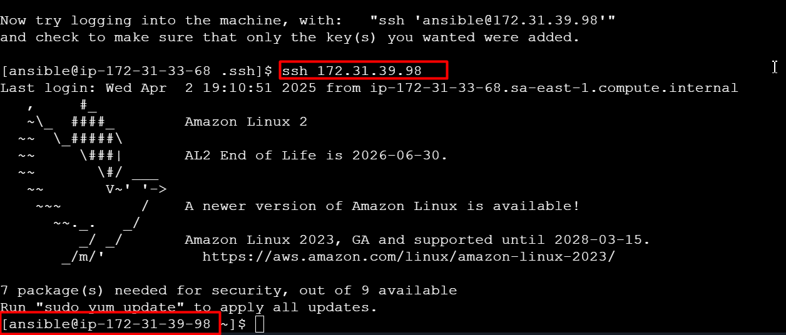
- Now you can check on host-server whether key is copied or not 👇
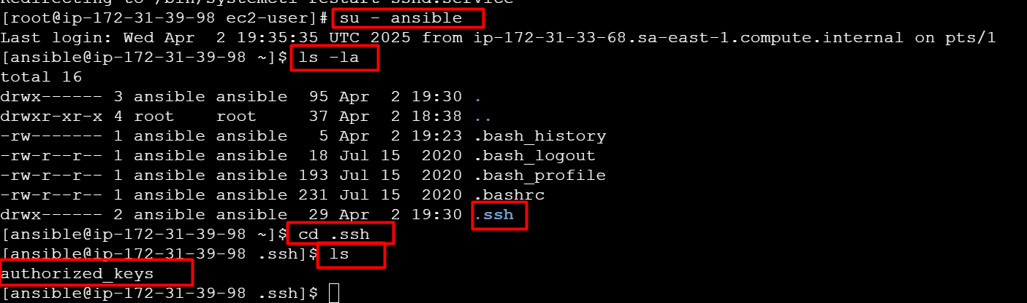

- Also you can check the connection from ansible-server using below command
ansible webservers -a “ls”
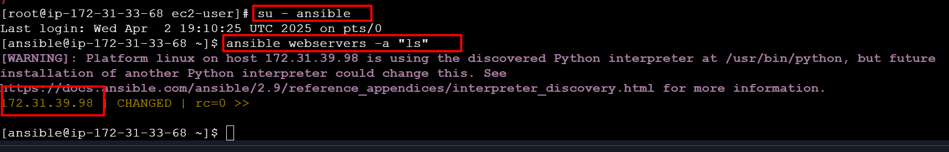

Lab set was done
========================================================

- Now we have to write playbooks use following script 👇
- Write playbooks on ansible-server only
- Create a file named with “my-demo-playbook.yaml”
vi my-demo-playbook.yaml
---
- hosts: webservers
user: ansible
become: yes
connection: ssh
tasks:

- name: install java on host machine
action: yum pkg=java state=present

- name: install mysql on host machine
action: yum pkg=mysql state=present

- name: install httpd on host machine
action: yum pkg=httpd state=present

- name: install docker on host machine
action: yum pkg=docker state=present

- name: install git on host machine
action: yum pkg=git state=present

# after installation is completed we can start services

- name: start httpd on host machine
action: service name=httpd state=started

- name: stop httpd on host machine
action: service name=httpd state=stopped

- name: restart httpd on host machine
action: service name=httpd state=started

- name: start docker on host machine
action: service name=docker state=started

- name: stop docker on host machine
action: service name=docker state=stopped

- name: restart docker on host machine
action: service name=docker state=started

- Now check syntax errors in your playbook
ansible-playbook <file-name> --syntax
- Next do a dry run before doing actual run
ansible-playbook <file-name> --check
- Now you can run your playbook
ansible-playbook <file-name>

---
- name: Deploy IPL-SRH static site on Apache
hosts: webservers
become: yes
remote_user: ansible
connection: ssh

tasks:
- name: Install Apache (httpd)
ansible.builtin.yum:
name: httpd
state: present

- name: Start and enable Apache service
ansible.builtin.service:
name: httpd
state: started
enabled: yes

- name: Copy index.html
ansible.builtin.copy:
src: /home/ansible/IPL-SRH/index.html
dest: /var/www/html/index.html
owner: root
group: root
mode: 0644

- name: Copy CSS files
ansible.builtin.copy:
src: /home/ansible/IPL-SRH/ipl_src_css/
dest: /var/www/html/ipl_src_css/
owner: root
group: root
mode: 0755

- name: Copy images
ansible.builtin.copy:
src: /home/ansible/IPL-SRH/images/
dest: /var/www/html/images/
owner: root
group: root
mode: 0755

---
This is the standard YAML document start indicator. It tells YAML parsers this is the beginning of a new document.

- name: Deploy IPL-SRH static site on Apache
👉 This begins a play in Ansible.
- name: is just a human-readable label so you know what this play is doing.

hosts: webservers
👉 This tells Ansible which group of hosts to run the play on.
- In your inventory file (inventory.ini), you defined a group called webservers.

become: yes
👉 This means Ansible should become root (via sudo) when running tasks, because installing packages or managing services needs elevated permissions.

remote_user: ansible
👉 This is the SSH user Ansible will use to connect to the target machines.
In your case you created an ansible user on the target EC2 instance.

connection: ssh
👉 Tells Ansible to use SSH for connections (the default, but you can be explicit).

tasks:
👉 Starts a list of tasks to execute on the target hosts.

- name: Install Apache (httpd)
👉 Human-friendly description of the first task.

ansible.builtin.yum:
name: httpd
state: present
👉 This uses the yum module to:
install the httpd package (Apache web server)
state: present means “make sure it is installed”.

- name: Start and enable Apache service
👉 Next task description — manage Apache’s service.

ansible.builtin.service:
name: httpd
state: started
enabled: yes
👉 Uses the service module to:
ensure the httpd service is running (state: started)
and it is enabled at boot (enabled: yes)

- name: Copy index.html
👉 Next task: copy the HTML home page to the web server directory.

ansible.builtin.copy:
src: /home/ansible/IPL-SRH/index.html
dest: /var/www/html/index.html
owner: root
group: root
mode: 0644
👉 Uses the copy module to:
copy index.html from your control node (the Ansible machine)
to the target node’s web root
set owner/group to root
set file permissions to 0644 (readable by everyone, writable by root)

- name: Copy CSS files
👉 Copies CSS assets in a similar way.

ansible.builtin.copy:
src: /home/ansible/IPL-SRH/ipl_src_css/
dest: /var/www/html/ipl_src_css/
owner: root
group: root
mode: 0755
👉 Copies the entire CSS directory to the web server.
0755 means read/execute by everyone, write for owner only.
This is fine for static assets like CSS.

- name: Copy images
👉 Copies the images directory to the server.

ansible.builtin.copy:
src: /home/ansible/IPL-SRH/images/
dest: /var/www/html/images/
owner: root
group: root
mode: 0755
👉 Again, standard directory copy, with safe permissions.
=======================================
# install Jenkins on target machine

sudo yum update -y
sudo amazon-linux-extras install java-openjdk11 -y
wget -O /etc/yum.repos.d/jenkins.repo \
https://pkg.jenkins.io/redhat-stable/jenkins.repo
sudo rpm --import https://pkg.jenkins.io/redhat-stable/jenkins.io-2023.key
sudo yum install jenkins -y
sudo systemctl enable jenkins
sudo systemctl start Jenkins
=========================================================
# execute this commands on ansible server
ansible-galaxy collection install amazon.aws

=====================================
# Jenkins pipeline script

pipeline {
agent any

environment {
ANSIBLE_INVENTORY = "/var/lib/jenkins/inventory.ini"
}

stages {
stage('Checkout') {
steps {
git 'https://github.com/Msocial123/IPL-SRH.git'
}
}

stage('Run Ansible Playbook') {
steps {
sh """
ansible-playbook -i ${ANSIBLE_INVENTORY} ${WORKSPACE}/ipl-playbook.yml
"""
}
}
}

post {
success {
echo '✅ Deployment successful!'
}
failure {
echo '❌ Deployment failed.'
}
}
}

